Nova AI Assistant

Project Brief — Nova AI Assistant

Project Name
Nova AI Assistant

Project Type
AI-powered SaaS — Knowledge & Customer Support Assistant

Project Overview
Nova AI Assistant is a SaaS platform that allows companies to provide an AI assistant capable of answering customer questions based on the company's own trusted information.
Each company can upload its documents, policies, FAQs, product information, and other materials. The system processes this information and creates a searchable Knowledge Base that the AI uses to answer customer questions.

Problem
Customers frequently have questions about a company's:
- Products
- Services
- Policies
- Shipping
- Returns
- Pricing
- FAQs
However, this information may be distributed across documents and other resources, requiring customers to search manually or contact customer support.
This can result in slower responses and increased workload for support staff.

Goal
The goal of Nova AI Assistant is to provide customers with fast, accurate, and context-aware answers based on the company's Knowledge Base, while reducing the need for manual customer support. The AI should avoid inventing information when the required information is not available.

Target Users

Company Admin
The person responsible for managing a company's AI assistant.
They can:
- Manage company documents.
- Upload new information.
- Update or delete existing information.
- Monitor document processing status.
- Manage the company's Knowledge Base.

End User / Customer
The person who interacts with the AI assistant.
They can:
- Ask questions.
- Receive AI-generated answers.
- Continue conversations using previous context.
- View relevant sources for answers.

7. SaaS Structure
The platform will support multiple companies.
Nova AI Platform
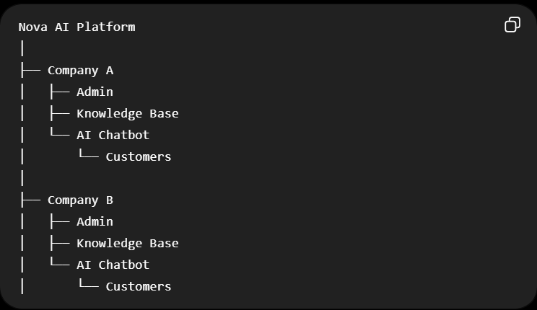
Each company will have its own Company ID, and its data must remain isolated from other companies.

8. Core Concept
The system follows this general flow:
Company Admin
↓
Upload Documents
↓
Document Processing
↓
Knowledge Base
↓
Customer asks a question
↓
Retrieve relevant information
↓
LLM
↓
Answer + Sources
The AI uses RAG (Retrieval-Augmented Generation) to retrieve relevant information from the company's Knowledge Base before generating an answer.

9. MVP
The first version will include:

Admin
- Authentication
- Upload documents
- View documents
- Update/delete documents
- View processing status

Customer
- Access AI Chat
- Ask questions
- Continue conversations
- View answers and sources

AI System
- Extract document content
- Chunk documents
- Generate embeddings
- Store/search relevant information
- Retrieve relevant context
- Generate answers using an LLM
- Avoid unsupported answers

System
- Authorization
- Multi-tenant data isolation
- Conversation history
- Error handling
- Logging
- Retry for failed processing

10. Out of Scope for MVP
- Payments
- Subscription billing
- Platform/Super Admin dashboard
- Advanced analytics
- Notifications
- Complex team management
- Advanced AI agents
- Large-scale infrastructure
- Advanced integrations

11. Expected Outcome
The MVP will allow a company to create an account, upload its information, and have the system process it. Customers can then ask questions, and the AI will retrieve relevant company information and generate an answer with its source.

User Stories — Nova AI Assistant
The following user stories define the main interactions and system behaviors required for the MVP of Nova AI Assistant. They are written using the standard format:
As a [user/actor], I want to [action], so that [benefit].

US-01 — Company Admin Authentication
As a Company Admin, I want to sign in securely so that I can access and manage my company's dashboard.

US-02 — Upload Documents
As a Company Admin, I want to upload company documents so that their information can be processed and used by the AI assistant.

US-03 — View Documents and Processing Status
As a Company Admin, I want to view uploaded documents and their processing status so that I can know which documents are ready to be used by the AI assistant.

US-04 — Update and Delete Documents
As a Company Admin, I want to update or delete company documents so that I can keep the Knowledge Base accurate and up to date.

US-05 — Ask the AI Assistant
As an End User, I want to ask the AI assistant questions so that I can quickly obtain information about the company's products, services, and policies.

US-06 — Continue a Conversation
As an End User, I want to continue a conversation with the AI assistant so that it can use the previous conversation context to understand follow-up questions.

US-07 — View Answer Sources
As an End User, I want to view the sources used for an AI-generated answer so that I can verify the information provided.

US-08 — Generate Knowledge-Based Answers
As a system, I want to generate answers based on the company's Knowledge Base so that the AI does not provide unsupported or fabricated information.

US-09 — Authorization and Data Isolation
As a system, I want to enforce authorization and data isolation so that users can only access the information and operations they are permitted to access.

US-10 — Error Handling and Logging
As a system, I want to handle errors safely and provide understandable error messages while recording detailed information in logs so that users can recover from failures and developers can troubleshoot problems.

Acceptance Criteria

Acceptance Criteria — US-01: Company Admin Authentication
AC-01 — Valid Credentials
- Given that the Company Admin has a registered account,
- When the Admin enters a valid email and password ,
- Then the system should authenticate the Admin successfully and redirect them to the Company Dashboard.
AC-02 — Invalid Credentials
- Given that the Admin enters incorrect login credentials,
- When they attempt to sign in,
- Then the system should reject the login attempt and display an understandable error message.
AC-03 — Unauthenticated Access
- Given that a user is not authenticated,
- When they attempt to access the Company Dashboard,
- Then the system should prevent access and redirect them to the login page.
AC-04 — Company Access
- Given that the Admin has successfully signed in,
- When the dashboard is displayed,
- Then the Admin should only be able to access data belonging to their company.

Acceptance Criteria — US-02: Upload Documents
AC-01 — Successful Upload
- Given that the Company Admin is authenticated and the selected file meets the supported format and size requirements.
- When the Admin uploads the document.
- Then the system should upload and store the document successfully.
- And display a success message to the Admin.
- And set the document status to UPLOADED.
AC-02 — Unsupported File Format
- Given that the Admin selects a file with an unsupported format.
- When the Admin attempts to upload it.
- Then the system should reject the upload.
- And display a clear message showing the supported file formats.
AC-03 — File Size Limit
- Given that the selected file exceeds the maximum allowed size.
- When the Admin attempts to upload it.
- Then the system should reject the upload.
- And display a clear message explaining the size limitation.
AC-04 — Upload Failure
- Given that an unexpected error occurs during the upload.
- When the upload fails.
- Then the system should display a clear error message to the Admin.
- And record the technical error details in the system logs.
- And allow the Admin to retry the upload.
AC-05 — Document Processing Status
- Given that the document has been uploaded successfully.
- When the document enters the processing pipeline.
- Then the Admin should be able to see its current processing status.
AC-06 — Successful Processing
- Given that the document has been processed successfully.
- When the processing is completed.
- Then the system should change the document status to READY.
- And the document's information should become available to the AI Knowledge Base.

Acceptance Criteria — US-03: View Documents and Processing Status
AC-01 — Documents Exist
- Given that the Company Admin has uploaded documents
- When the Admin opens the Documents page
- Then the system should display the documents belonging to their company.
AC-02 — No Documents
- Given that the Company Admin has not uploaded any documents
- When the Admin opens the Documents page
- Then the system should display an appropriate empty-state message.
AC-03 — Processing Status
- Given that documents exist
- When the Admin views the Documents page
- Then the system should display the current processing status of each document, such as UPLOADED, PROCESSING, READY, or FAILED.
AC-04 — Data Isolation
- Given that multiple companies use the system
- When a Company Admin views the Documents page
- Then the system should display only documents belonging to their company.

Acceptance Criteria — US-04: Update/Delete Documents
AC-01 — Update an Existing Document
- Given that the Company Admin selects an existing document
- When the Admin uploads an updated version
- Then the system should replace the previous version and start processing the updated document.
AC-02 — Reprocess Updated Content
- Given that a document has been updated
- When processing is completed
- Then the Knowledge Base should contain the updated information and the previous version should no longer be used for AI responses.
AC-03 — Delete a Document
- Given that the Company Admin selects an existing document
- When the Admin confirms the deletion
- Then the system should remove the document and its associated information from the company's Knowledge Base.
AC-04 — Prevent Unauthorized Modification
- Given that a document belongs to another company
- When the Admin attempts to update or delete it
- Then the system should deny the operation.
AC-05 — Update or Delete Failure
- Given that an error occurs during an update or deletion
- When the operation fails
- Then the system should notify the Admin without corrupting or partially removing the existing document data, and record the error for troubleshooting.

Acceptance Criteria — US-05: Ask the AI Assistant
AC-01 — Submit a Question
- Given that the End User has access to the AI Assistant
- When the user submits a question
- Then the system should process the question and return an appropriate response.
AC-02 — Relevant Answer
- Given that relevant information exists in the company's Knowledge Base
- When the user asks a related question
- Then the system should provide an answer based on the relevant information.
AC-03 — No Relevant Information
- Given that the Knowledge Base does not contain sufficient information to answer the question
- When the user submits the question
- Then the system should clearly state that the information could not be found instead of generating an unsupported answer.

Acceptance Criteria — US-06: Continue a Conversation
AC-01 — Conversation Context
- Given that the user has an existing conversation
- When the user submits a follow-up question
- Then the system should use relevant previous messages to understand the context.
AC-02 — Conversation History
- Given that a conversation contains previous messages
- When the user returns to the conversation
- Then the system should display the previous messages in the correct order.
AC-03 — Independent Conversations
- Given that the user has multiple conversations
- When the user opens a specific conversation
- Then the system should use only the relevant context from that conversation.

Acceptance Criteria — US-07: View Answer Sources
AC-01 — Display Sources
- Given that an AI response is based on information retrieved from the Knowledge Base
- When the response is displayed
- Then the system should provide the relevant source or document reference.
AC-02 — Source Accuracy
- Given that a source is displayed for an answer
- When the user selects the source
- Then the system should identify the document or information from which the relevant content was retrieved.
AC-03 — No Available Source
- Given that no relevant information is retrieved
- When the AI generates the response
- Then the system should not display a misleading or unrelated source.

Acceptance Criteria — US-08: Generate Knowledge-Based Answers
AC-01 — Retrieve Relevant Information
- Given that the company has processed documents in its Knowledge Base
- When a user asks a question
- Then the system should retrieve information relevant to the question before generating the answer.
AC-02 — Knowledge-Based Response
- Given that relevant information has been retrieved
- When the AI generates the response
- Then the response should be based on the retrieved company information.
AC-03 — Prevent Unsupported Answers
- Given that sufficient information is not available in the Knowledge Base
- When the AI processes the question
- Then the system should avoid presenting unsupported information as fact.
AC-04 — Company-Specific Knowledge
- Given that multiple companies use the platform
- When the AI processes a question
- Then it should use only the Knowledge Base belonging to the relevant company.

Acceptance Criteria — US-09: Authorization and Data Isolation
AC-01 — Role-Based Access
- Given that users have different roles
- When they access the system
- Then the system should allow only the operations permitted for their role.
AC-02 — Company Data Isolation
- Given that multiple companies use the platform
- When a user accesses company data
- Then the system should restrict access to data belonging to their authorized company.
AC-03 — Unauthorized Operations
- Given that a user does not have permission to perform an operation
- When they attempt to perform it
- Then the system should deny the operation.
AC-04 — Unauthorized Data Access
- Given that a user attempts to access another company's documents, conversations, or Knowledge Base
- When the request is processed
- Then the system should deny access.

Acceptance Criteria — US-10: Error Handling and Logging
AC-01 — User-Friendly Error Messages
- Given that an operation fails
- When an error occurs
- Then the system should display a clear and understandable message to the user.
AC-02 — Error Logging
- Given that an unexpected system error occurs
- When the error is detected
- Then the system should record relevant technical details in the system logs for troubleshooting.

AC-03 — Data Integrity
- Given that an operation fails during processing
- When the failure occurs
- Then the system should prevent incomplete or corrupted data from being stored.
AC-04 — Retry Failed Operations
- Given that an operation can safely be retried
- When the operation fails
- Then the system should allow or perform a retry without creating duplicate or inconsistent data.

System Architecture
The Nova AI Assistant will follow a layered architecture consisting of a web frontend, backend API, database, file storage, and AI services.
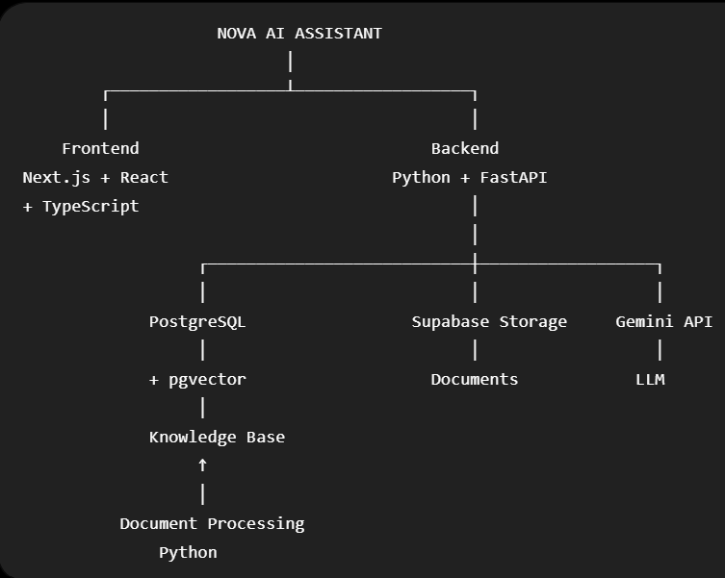
The backend will act as the central layer connecting the frontend with the database, storage, document processing, and AI services.

Technology Stack
The Nova AI Assistant will use the following technologies:
- Frontend: Next.js, React, and TypeScript.
- Backend: Python and FastAPI.
- Database: PostgreSQL with pgvector for vector search.
- File Storage: Supabase Storage.
- AI/LLM: Gemini API.
- Authentication: Supabase Auth.
- Authorization: FastAPI and PostgreSQL RLS.
- Document Processing: Python.
- Containerization: Docker and Docker Compose.
- Version Control: Git and GitHub.
- API Documentation: OpenAPI and Swagger UI.

Database Design ERD:
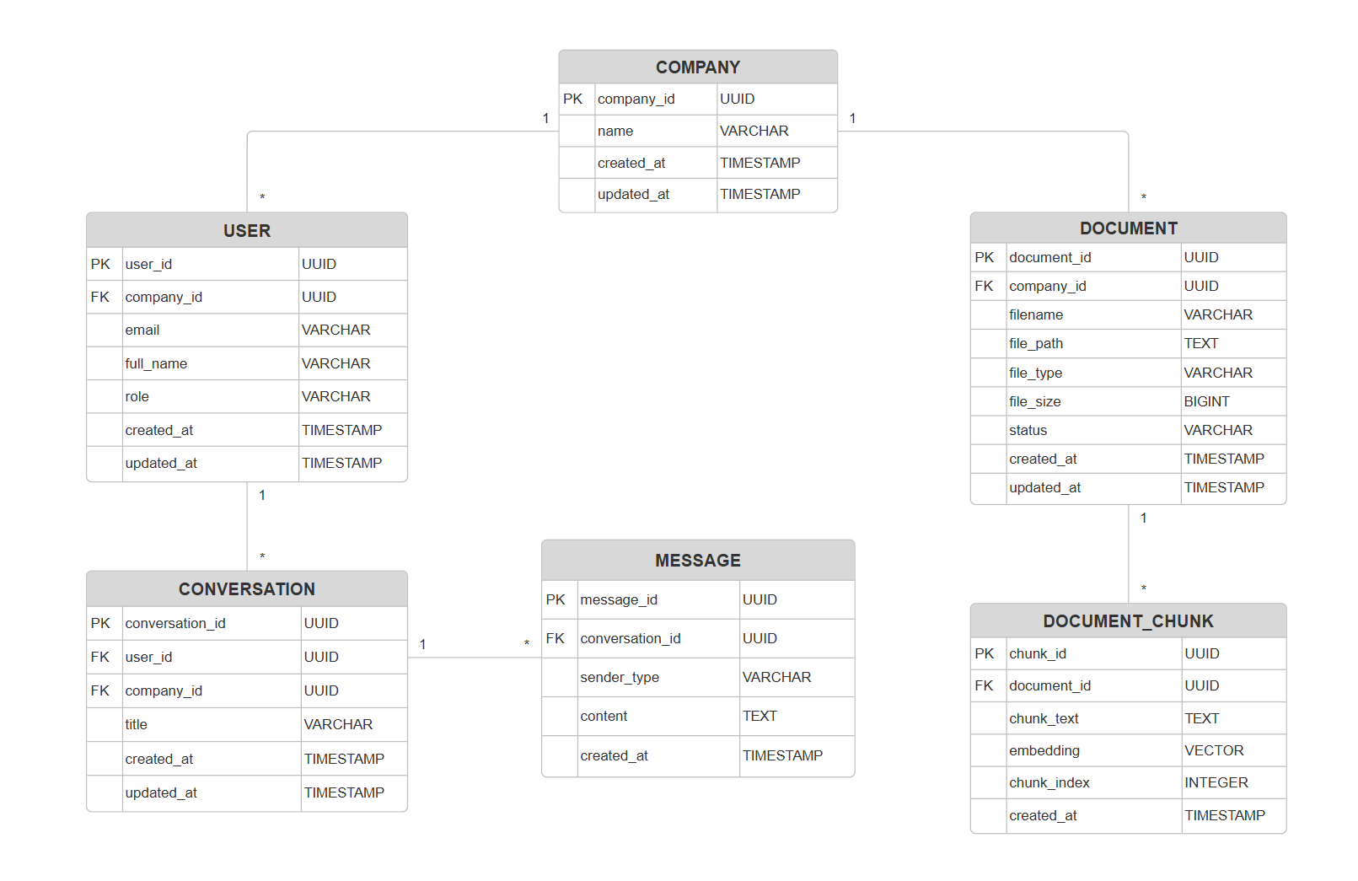

company_id add to document_chunk

API Design:
DOCUMENTS:
- POST /documents
- GET /documents
- GET /documents/{id}
- PUT /documents/{id}
- DELETE /documents/{id}
CONVERSATIONS:
- POST /conversations
- GET /conversations
- GET /conversations/{id}
- DELETE /conversations/{id}
MESSAGES:
- POST /conversations/{id}/messages

GET /conversations/{id}/messages
RAG / AI Workflow
The Nova AI Assistant uses a Retrieval-Augmented Generation (RAG) approach:
- Document Processing: Uploaded documents are processed by extracting their text.
- Chunking: The extracted text is divided into smaller chunks.
- Embeddings: Each chunk is converted into a vector representation.
- Vector Storage: Chunks and their embeddings are stored in PostgreSQL using pgvector.
- Question Processing: The user's question is converted into an embedding.
- Vector Search: The system retrieves the most relevant document chunks.
- AI Generation: The retrieved information is provided to the Gemini LLM to generate the answer.
- Sources: The system returns the answer with the relevant document sources.
- Unsupported Information: If sufficient information is not available, the system will avoid generating unsupported answers.
Workflow:
Document:

- Text Extraction
- Chunking
- Embeddings
- Vector Storage
User Question:

- Embedding
- Vector Search
- Relevant Chunks
- Gemini LLM
- Answer + Sources

Development Environment:

- Code Editor: VS Code / Codex
- Version Control: Git + GitHub
- Containerization: Docker + Docker Compose
- Environment Variables: .env
- API Testing: Swagger UI / OpenAPI
- Development Environment: Local development
- Deployment Environment: Production deployment will be considered after MVP development and testing.

UI Design
The Nova AI Assistant will provide separate interfaces for Company Admins and End Users.
- Company Admin Interface: Provides secure access to the dashboard, document management, document upload, and document processing status.
- End User Interface: Provides an AI chat interface for asking questions, viewing responses and sources, and accessing conversation history.
- Navigation: Users will only access features and screens permitted by their roles.
Main User Flows:
- Company Admin:

Login → Dashboard → Documents → Upload / Manage Documents

- End User:

Access Company Chat bot → Ask Question → AI Answer + Sources → Continue Conversation → Conversation History

